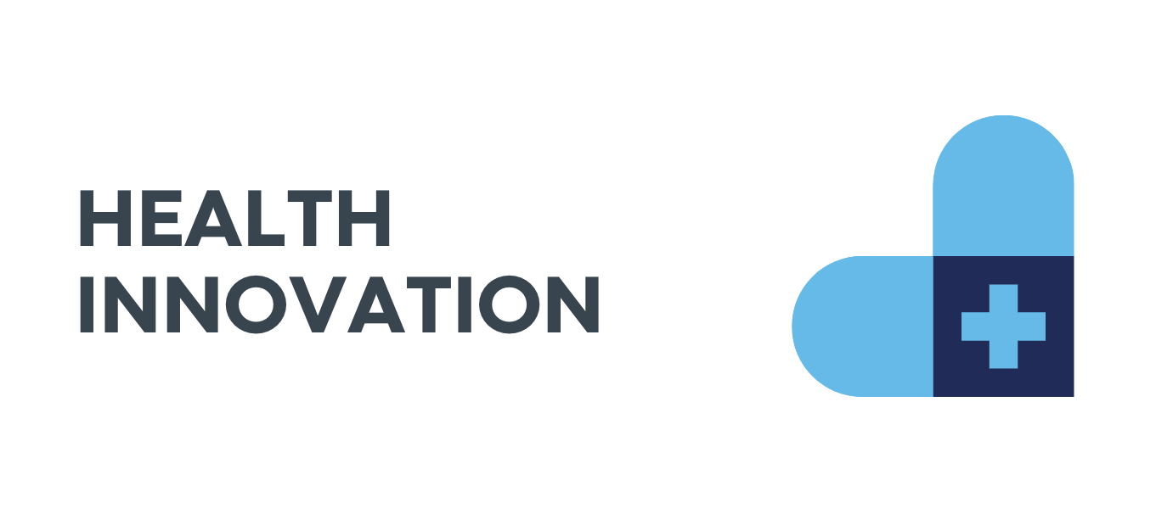
BRAND A BAND

INTRODUCTION
For my first project, my team and I worked on branding for the Health Innovation minor at Fontys. The client wanted us to inspire and educate students about the potential of health innovation. By showcasing the value of the Health Innovation Minor, you aim to create a pathway for students to explore cutting-edge solutions in healthcare and drive change in the healthcare sector.

The first week me and my teammates had the task to make an Exel table with our own Strengths and Weaknesses, that way we all get to learn more about our group. And will also help us know how to divide the upcoming tasks in the project by knowing each others strengths.

Next we started off by making the Project Plan. We all took part in the making of it, we brainstormed and gave ideas what to create in the project, everyone suggested themselves for different tasks, saying what they are good at or want to learn. We not only planned the week ahead of us but the following ones.

After that, we moved on with the Content Strategy. We divided sections to one another so everyone has a part. I helped present the forms, letting our client know what the mission and vision is.

My teammate Miya created a Trello Board in which I helped her organize. We gave tasks to everyone and thought how important the task is so we know when we should be done with it.

Later on the first week we already started working on the Stylescapes. We divide the group into two smaller ones, making me work with Miya and Justin. The three of us made our own design and then combined into a shared one with our own touches.
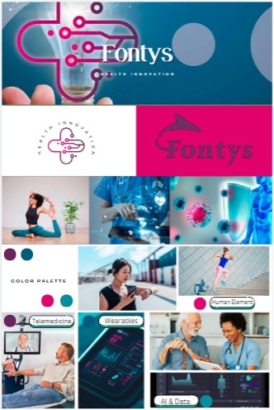
Before starting anything, I researched what stylescapes are, because it was my first time and I wasn’t familiar with their concept. I understood that it is a type of post that is combined of the same themed images of the brand you are promoting. So that is why I searched for images that are connected to health. When I think of health I see blue and green. But because I wanted to add the Fontys’ logo which is purple I stuck with using blue instead of green, because I don’t think green and purple would have looked good together. I as well did a poster for the project. I focused mainly in the color blue, making it look more tech. I wasn’t happy with the end result so that is why I would like to do it again.

After the stylescapes we moved on creating logos for the client. Again we started working individually and then we discussed which one is the most suitable for us to chose for a final one.
My thoughts were to create something simple and in the color palette we picked out.

I searched on Pinterest for some inspiration and saw a lot of plus signs +, I really liked the idea because like that when people look at it they think of positivity.
I chose the color light blue as the main color in my logo so it could stand out and be more noticeable. I liked how it turned out because when it is not a very complicated design it will be easier for our client to use in other products. Also it is easily remebered for the audience.

Next Miya started off making a survey and I dicided to help out with the making of it and also handing it to more people. We focused on asking questions on the apperence and contect of the website she and Justin were making for the project. We got feedback from Frank about it and he wasn’t very satisfied with the questions we chose, he explained that asking questions about the colors of the website isnt needed and that we should chose our own design because we are the creators of the product for the client.

Next I had the task to create the promo video. I was very excited to do it because I have always found it intresting to know how people do it.
I started researching on Google to see what the general description is, so the vision in my head clears up.
After that, I searched on Pinterest, because it is a well-known source for designs and others, but unfortunately, I didn’t find many ideas there, and therefore I moved to TikTok and Instagram.
TikTok was more helpful for me because there were a lot of tutorials, explanations, and just promo videos in general.
I noticed that they use something that would grab your attention in the beginning.
I also noticed that the main focus was to not look like an ad, so people don’t automatically skip.
I started off with an idea of just someone holding a phone, and on the screen, it promotes our project.
I found a green-screen phone video, worked with CapCut and InShot, and made a lot of changes because, once in a while, I didn’t like how it looked, either because of the angle, color, or image.
I got a clip from TikTok of a girl knocking on the screen and added it to the phone screen.
After that, I searched on YouTube for some images or short clips of Fontys. I tried adding some health-related clips into it because the project was about the health innovation minor in Fontys, but I didn’t end up finding any to my liking.
It took me quite some time and patience, but in the end, I was very happy with the result.
We asked Anke for an opinion, and she told us that the title in the beginning wasn’t very clear. We saw what she meant and agreed, so I changed it to another, more suitable one.
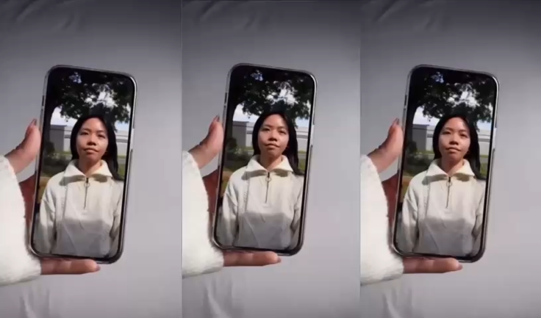
In the end, the client didn’t expect to see a promo video, or at least such a long one, so he was very happily surprised and said he really liked the video and would totally use it.

The final thing I did was the presentation. I made two because we had to present our product twice. Once in the beginning so we get some feedback from the client and the second time at the end when we show our finalized product. 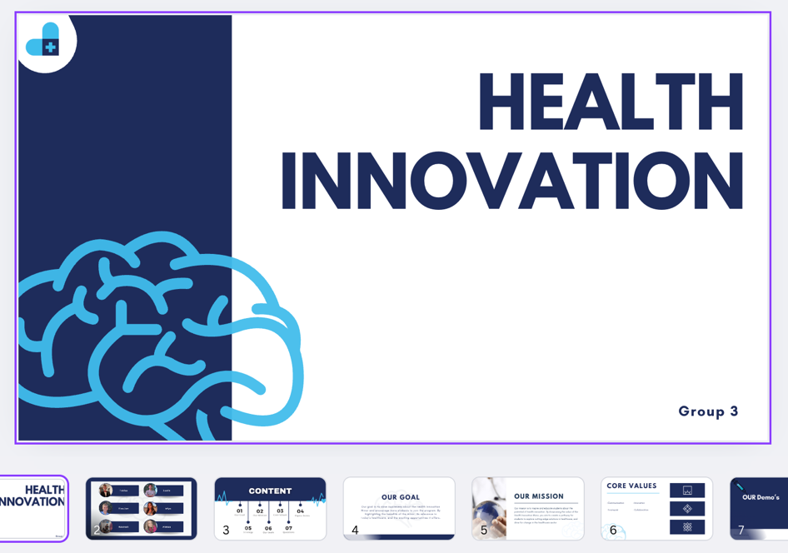
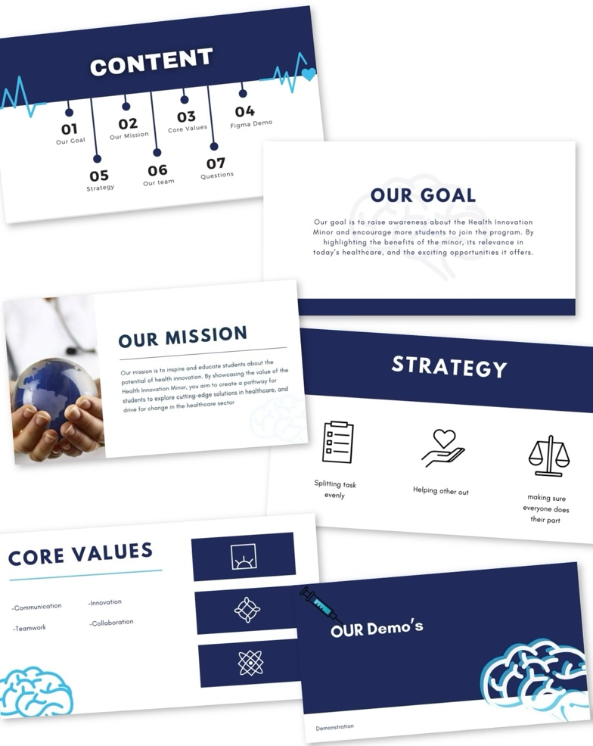

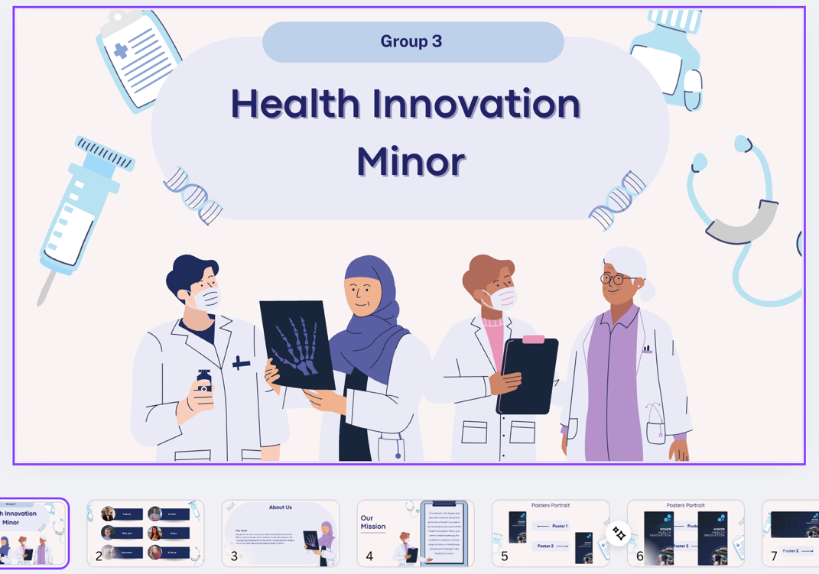
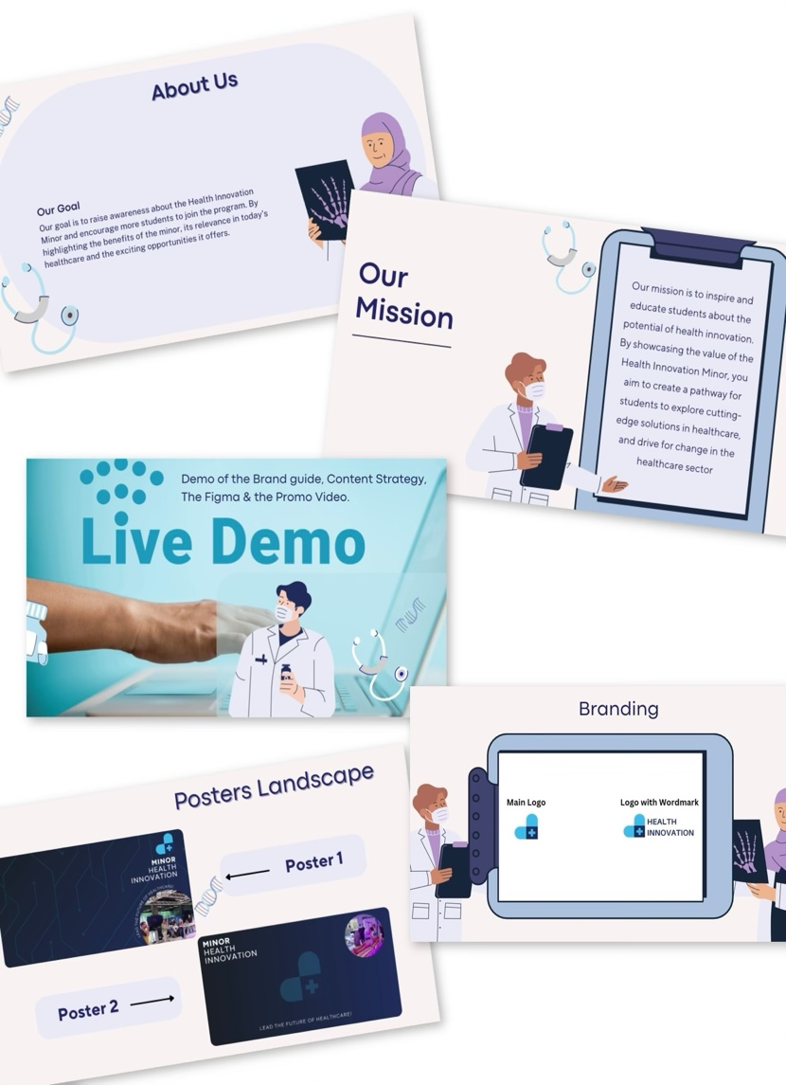
Before starting making the presentations I read over what the client has provided as information, I research on the topic “health innovation”, I go in Fontys’ website and read more about the minor there. After I have gathered enough information I started looking at some inspiration for how the presentation should look like. I couldn’t find any designs in particular that I liked, so then I went into Canva and started creating my own presentation with health related characters. I continued with our color pallet, kept it simple but noticeable and simplified the text so there isn’t too much on the screen making it hard to read.
After all of that was done I started dividing the slides to all of my group members, of course also asking them if they are okay with the slides given.

OVERALL
As my very first group project in my second semester I really enjoyed it, I learned new stuff that I also enjoyed creating.
The promo video was definitely my favorite part. If I have to do this project over again I would probably try to participate even more than I already did, I would redo the poster I made and make more stylescapes.

